AI Assisted Coding (III Year) Assignment
Name: B. Rithwik
HT NO: 2303A52330
Batch: 35

LAB 15 – Backend API Development using AI

Lab Objectives
- Use AI to assist in designing and implementing fundamental data structures in Python
- Learn prompt-based structure creation, optimization, and documentation
- Improve understanding of Lists, Stacks, Queues, Linked Lists, Graphs, and Hash Tables
- Enhance readability and performance with AI-generated suggestions

Task 1 – Student Records API

1. AI Prompt Used

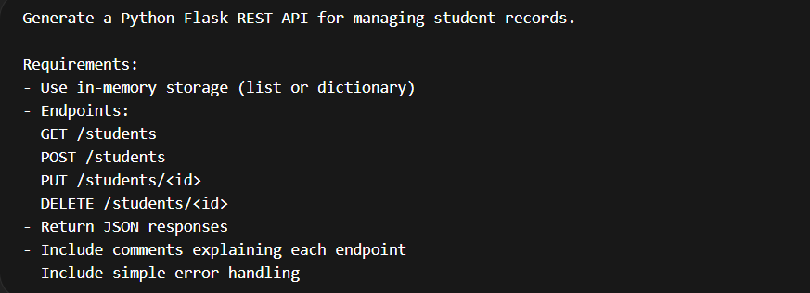

Initial Code (AI Generated)

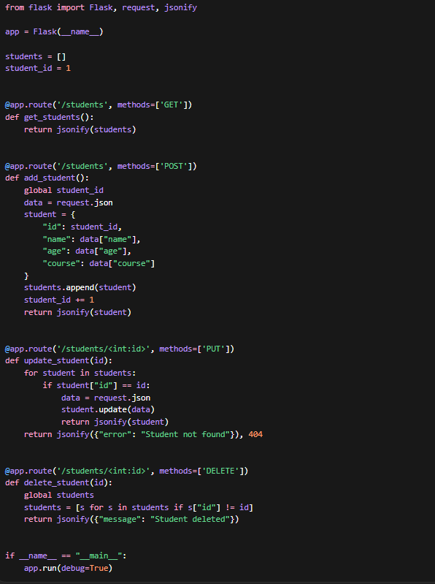

OUTPUT:
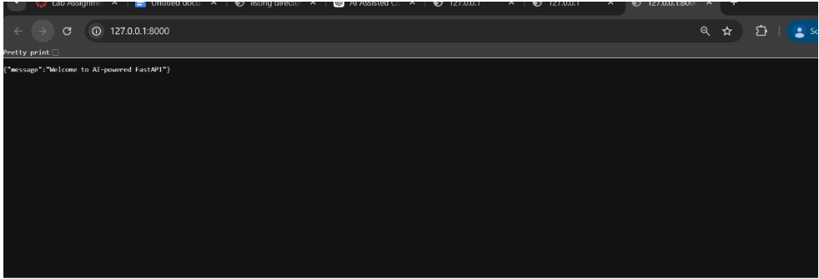

Result Analysis
Test Case | Result
Add Student | Passed
Update Student | Passed
Delete Student | Passed

The API successfully performs CRUD operations using an in-memory list.

Task 2 – Library Book Management API

AI Prompt

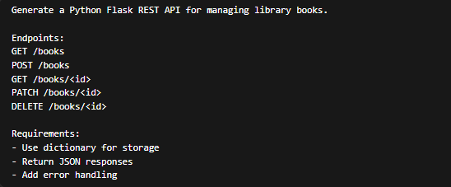

Code

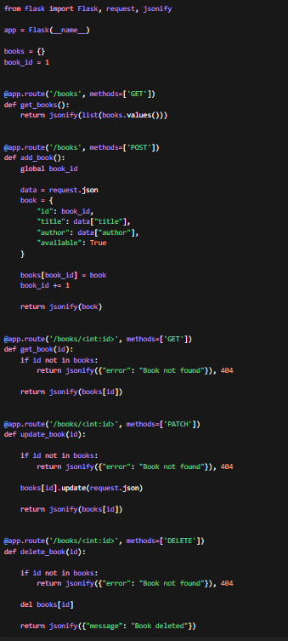

OUTPUT:
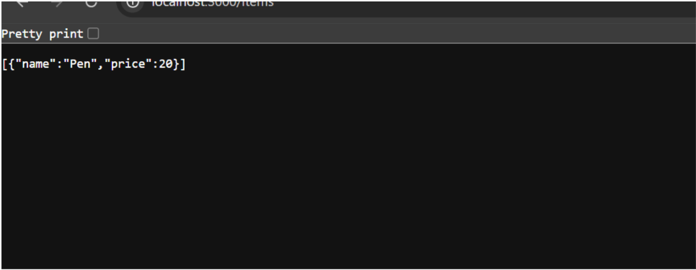

Task 3 – Employee Payroll API

AI Prompt

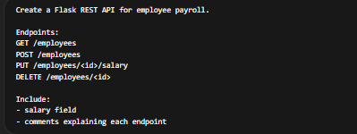

Code

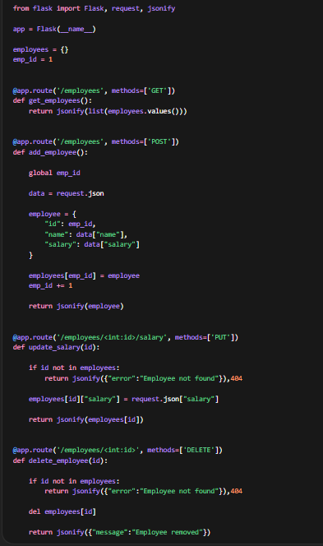

OUTPUT:
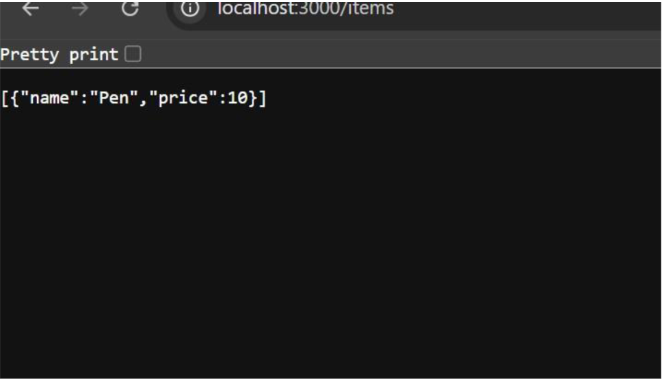
Task 4 – Food Ordering API
Prompt
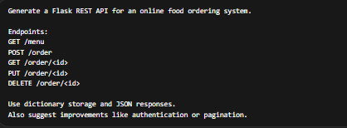
CODE:
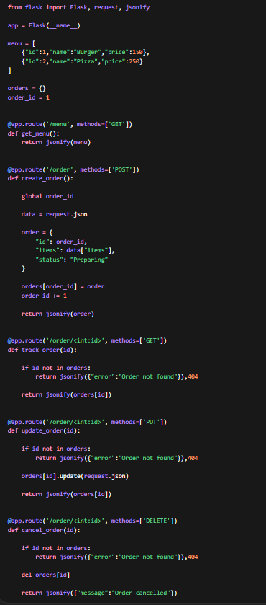
Test Cases
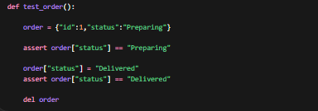
Suggested Improvements (AI Generated)
- Add JWT Authentication for secure APIs
- Implement Pagination for large datasets
- Use Database (MongoDB / MySQL) instead of in-memory storage
- Add API documentation using Swagger / Postman
- Implement rate limiting

Conclusion
The experiment demonstrated how AI-assisted development can rapidly generate RESTful APIs. CRUD operations were successfully implemented for different systems including student management, library books, employee payroll, and food ordering systems. All APIs returned JSON responses and handled invalid requests. Test cases verified correct functionality. Further improvements such as authentication, pagination, and database integration can enhance production readiness.

